

**M.A.M COLLEGE OF ENGINEERING AND TECHNLOGY**

**ChatConnect - A Real-Time Chat and Communication App**

**TEAM LEADER :**

**SUKUMAR A - 812022104080**

**TEAM MEMBERS :**

**RUBAN RAJ N - 812022104064**

**SATHISH P - 812022104068**

**RISHWAN AHEMAD S -812022104063**

|  |  |  |
| --- | --- | --- |
| **S.NO** | **CONTENT** | **PAGE NO** |
| 1. | Abstract | O3 |
| 2. | Introduction | 03 |
| 3. | Software Required | 04-05 |
| 4. | Hardware Required | 06-08 |
| 5. | Working Procedure | 08-10 |
| 6. | Source Code | 10-18 |
| 7. | Output | 19-20 |
| 8. | Benefits | 20-21 |
| 9. | Conclusion | 21 |
| 10. | References | 22 |

**Abstract**

The increasing demand for instant communication in today’s fast-paced digital world has given rise to numerous chat applications. However, many of these apps either lack efficiency, user experience, or data security. ChatConnect aims to bridge this gap by providing a robust, real-time chat application that combines high performance with a secure communication environment.

ChatConnect focuses on facilitating smooth and instant communication through features like one-on-one messaging, group chats, multimedia sharing, and notifications. The app is built with scalability in mind, ensuring that it can handle a large number of users without compromising performance. Security is a top priority, with end-to-end encryption, secure user authentication, and data privacy mechanisms integrated into the system.

The project leverages modern technologies such as WebSocket for real-time communication and cloud databases for efficient data storage and retrieval. The user interface is designed to be intuitive, offering a seamless experience across multiple devices and platforms. By incorporating a clean, responsive design and optimizing for performance, ChatConnect aims to deliver an experience that is both user-friendly and technically superior.

This project not only addresses the current needs of instant messaging but also anticipates future advancements by being adaptable and extensible. With a focus on efficiency, scalability, and security, ChatConnect is positioned to become a reliable solution for both personal and professional communication.

**Introduction**

In the era of digital transformation, communication has become one of the most critical aspects of our daily lives. With the growing need for instant and seamless interaction, chat applications have emerged as a vital tool for staying connected in both personal and professional spheres. However, many existing chat solutions often face limitations in areas such as performance, scalability, security, and user experience. This is where **ChatConnect** steps in, aiming to address these challenges by offering a real-time chat and communication platform that is fast, reliable, and secure.

**ChatConnect** is designed to facilitate effortless communication by providing features such as real-time messaging, group chats, multimedia sharing (images, videos, documents), and customizable notifications. The application is built on a modern tech stack using WebSocket technology to enable instant message delivery, ensuring that users experience minimal latency and smooth communication. The platform also focuses heavily on user data security with measures like end-to-end encryption and secure authentication protocols.

The primary objective of this project is to create a chat application that not only meets but exceeds user expectations in terms of performance and reliability. By leveraging scalable cloud infrastructure, ChatConnect can support a large number of concurrent users without compromising speed or functionality. Additionally, the intuitive user interface is designed to provide a seamless experience across various devices, ensuring accessibility and convenience.

As digital communication continues to evolve, ChatConnect is envisioned as a future-proof solution, capable of integrating new features and adapting to technological advancements. This project aims to set a new standard for real-time communication by focusing on efficiency, security, and an exceptional user experience.

**SOFTWARE REQUIREMENT:**

The following are the software requirements needed to build, run, and maintain the **ChatConnect** real-time chat and communication application. These include the development tools, programming languages, frameworks, databases, and other software components required to ensure the application's functionality, performance, and security.

**1. Programming Languages**

* **JavaScript (Node.js)**: Used for building the backend services, particularly for WebSocket connections, and handling real-time messaging.
* **Kotlin**: The primary programming language for Android development to build the mobile app.
* **Swift**: For building the iOS version of the mobile app, ensuring cross-platform compatibility and a native app experience.
* **HTML/CSS/JavaScript (React)**: Used to build the frontend web interface of the chat application. React is chosen for its component-based architecture and scalability.

**2. Frameworks and Libraries**

* **Node.js**: The backend framework for creating a scalable, event-driven, and non-blocking I/O system. It powers the WebSocket server for real-time communication.
* **Express.js**: A minimal web framework for Node.js used to create RESTful APIs for managing user data, chat history, and authentication.
* **Socket.io**: A library for real-time, bi-directional communication between web clients and servers, used to implement WebSocket communication for instant messaging.
* **Room (Android)**: For creating the Android app with persistent storage and offline capabilities. It is used to store chat history, user data, and settings in a local database.
* **Firebase**: Used for real-time database functionality, user authentication (via Firebase Authentication), and cloud messaging services.
* **Spring Boot (optional)**: If additional server-side functionality is needed for complex backend operations, Spring Boot can be used with Java for API services.

**3. Databases**

* **Firebase Firestore**: A NoSQL cloud database that stores user data, chat messages, and media files in real-time. It enables scalability and synchronization across devices.
* **SQLite**: For local data storage in the mobile apps (Android and iOS), SQLite stores chat history and user preferences when offline.

**4. Development Tools**

* **Android Studio**: The official IDE for Android development, used to create, test, and debug the mobile app.
* **Xcode**: The IDE for iOS development used for building and testing the iOS version of the app.
* **Visual Studio Code (VS Code)**: A lightweight code editor used for writing backend services, APIs, and frontend web code.
* **Git/GitHub**: Version control system for managing the project's codebase, collaboration, and deployment.
* **Postman**: Used for testing API endpoints and ensuring backend services work as expected.
* **Docker**: For containerizing the backend services, ensuring consistent environments across development and production systems.

**5. Authentication and Security**

* **OAuth 2.0**: For secure user authentication, enabling single sign-on (SSO) and access control mechanisms.
* **JWT (JSON Web Tokens)**: For secure communication between the client and server, ensuring that users are authorized to send and receive messages.
* **SSL/TLS Encryption**: For securing communication between the client and server, ensuring that data exchanged is encrypted and protected from unauthorized access.

**6. Hosting and Cloud Services**

* **Google Cloud Platform (GCP)** or **Amazon Web Services (AWS)**: For hosting the backend services, databases, and media files. Cloud services offer scalability, reliability, and global distribution to support large user bases.
* **Firebase Cloud Messaging (FCM)**: For sending push notifications to users about new messages or updates.
* **Heroku**: A platform-as-a-service (PaaS) used for deploying the backend application if a simpler hosting solution is required for smaller-scale projects.

**7. Testing Tools**

* **JUnit**: A widely used testing framework for Java, used to test backend services and functions.
* **Espresso**: A testing framework for Android apps, ensuring that the mobile app works seamlessly.
* **Appium**: An open-source testing tool for mobile apps, useful for automating UI tests on Android and iOS devices.
* **Selenium**: A testing tool used to automate the web app's frontend for functional and regression testing.

**8. Other Software**

* **Redis**: A caching tool used to store frequently accessed data such as user statuses, to reduce load times and improve performance.
* **Nginx**: A web server and reverse proxy server that can be used to load balance traffic and ensure high availability and scalability of the backend services.

**HARDWARE REQUIREMENT:**

The hardware requirements for developing, deploying, and running the ChatConnect real-time chat and communication application include the necessary infrastructure for both the development environment and the deployment environment. These requirements will ensure optimal performance, reliability, and scalability of the application.

**1. Development Hardware**

These are the hardware specifications required for developers to build and test the application.

For Android Development (Mobile App)

* **Processor**: Intel Core i5 (or equivalent) or higher, with at least 2.5 GHz clock speed.
* **RAM:** 8 GB or more for smooth multitasking and running Android Studio efficiently.
* **Storage**: 256 GB SSD or higher for fast read/write speeds, particularly for storing project files and emulator images.
* **Graphics:** Integrated graphics or a dedicated GPU (e.g., Nvidia GeForce GTX) for rendering the Android emulator and other graphics-related tasks.
* **Operating System:** Windows 10 (64-bit), macOS (latest version), or Linux (Ubuntu recommended) for Android Studio and emulators.

**For iOS Development (Mobile App)**

* **Processor:** Apple M1/M2 or Intel Core i5/i7 with 2.5 GHz clock speed or higher.
* **RAM:** 8 GB or more, but 16 GB is recommended for smooth Xcode operation.
* **Storage:** 256 GB SSD or more for storing large iOS project files and app simulators**.**
* **Graphics**: Integrated graphics or a dedicated GPU for Xcode and design tasks.
* **Operating System:** macOS (latest version) for compatibility with Xcode and iOS simulators.

**For Web Development (Frontend)**

* **Processor:** Intel Core i5 (or equivalent) or higher.
* **RAM:** 8 GB or more, to handle large codebases and browser processes.
* **Storage:** 256 GB SSD or higher, for code storage and web assets.
* **Graphics:** Integrated graphics or a dedicated GPU to handle web design and layout rendering.
* **Operating System:** Windows 10 (64-bit), macOS, or Linux (Ubuntu preferred).

**2. Server Hardware Requirements**

These hardware specifications are necessary for hosting and deploying the backend services and ensuring scalability, availability, and performance in production environments.

**For Backend Server (Hosting Application and Database)**

* **Processor:** Intel Xeon or AMD Ryzen processor with at least 4-8 cores and 2.5 GHz clock speed, or equivalent.
* **RAM:** Minimum 16 GB or more (32 GB recommended) for handling large-scale real-time messaging and user requests.
* **Storage:** SSD with at least 1 TB of storage for fast database reads/writes and storing large media files (photos, videos, etc.).
* **Network:** High-speed internet connection with at least 1 Gbps bandwidth for handling multiple concurrent connections and ensuring low-latency communication.
* **Operating System:** Ubuntu 20.04 or later, CentOS, or other Linux distributions for optimal performance and security.
* **GPU (Optional):** If using machine learning models for message analysis, user behavior predictions, or chatbots, a GPU with at least 4 GB of VRAM (e.g., Nvidia GTX 1660 Ti or higher) is recommended.

**For Media Storage (Cloud or On-Premises)**

* **Cloud Storage:** Cloud providers like Google Cloud Storage, AWS S3, or Firebase Cloud Storage, where scalable storage is needed for media files (images, videos, etc.) uploaded by users.
* **On-Premises Storage:** If choosing on-premises, enterprise-grade storage devices like Network Attached Storage (NAS) with multiple terabytes of space and fast network connectivity should be used.

**For Real-Time Messaging and Push Notification Server**

* **Processor:** Multi-core processors (4-8 cores) for handling high concurrency with low latency.
* **RAM:** Minimum 16 GB, scalable as required to handle the load.
* **Network:** High-bandwidth and low-latency network connection (1 Gbps or higher) for real-time communication.
* **Operating System:** Linux-based server, preferably Ubuntu, for running Node.js, WebSocket servers, and other communication tools.

**3. Testing Devices**

Testing the ChatConnect application requires various mobile devices and systems to ensure compatibility across platforms and devices.

**For Android Testing**

* **Device Models:** A range of Android devices with different screen sizes and configurations (e.g., 4-inch to 7-inch screens, various Android versions).
* **Emulators:** For testing on different Android versions and configurations.
* **OS:** Android 10 or later on physical devices for real-world testing of push notifications and real-time messaging.

**For iOS Testing**

* **Device Models**: iPhone 8 or later, iPad Pro (for testing on larger screen sizes).
* **Emulators:** Used for testing across different iOS versions and device models.
* **OS:** iOS 12 or later for compatibility with the latest iOS features.

**4. Optional Hardware for Scaling and High Availability**

* **Load Balancer:** Hardware or software load balancer to distribute traffic across multiple backend servers for better scalability.
* **Web Servers:** For routing client requests, Apache or Nginx can be set up on the server infrastructure.
* **Backup Systems:** Regular backups of the application database and media storage are important for disaster recovery. On-premise storage solutions or cloud-based backup services can be used.

**5. Additional Requirements**

* **Power Backup**: Uninterruptible power supplies (UPS) are necessary for the servers and workstations to ensure continuous operation during power failures.
* **Security Hardware:** Firewalls, intrusion detection systems (IDS), and other security appliances are necessary to protect data and communications in the server infrastructure.

**WORKING PROCEDURE:**

The ChatConnect app follows a structured working procedure that ensures smooth communication between users in real-time. Below is a step-by-step breakdown of how the app works from the user's initiation of the app to the final message delivery.

**1. User Authentication and Registration**

* **Step 1:** When a user opens the app for the first time, they are presented with a login/registration screen.
* **Step 2**: If the user is new, they can sign up by providing details such as username, email, and password.
* **Step 3**: The app validates the credentials and creates a new account in the backend database.
* **Step 4:** If the user already has an account, they can log in using their credentials (username/email and password).
* **Step 5**: Upon successful authentication, the app grants access to the main chat interface.

**2. Real-Time Messaging and Chat Interface**

* **Step 6:** After authentication, users can access the main chat screen where they can select existing contacts or create new chats.
* **Step 7**: When a user selects a contact, a chat interface is loaded, showing past conversations, if any.
* **Step 8**: The user can type and send messages in real-time. Messages are sent using WebSockets for low-latency communication.
  + WebSocket Connection: The app maintains a persistent WebSocket connection between the client (mobile or web app) and the server to send and receive messages instantly.
  + Message Flow: When a user sends a message, it is encrypted and transmitted to the server, which then forwards it to the recipient's device via WebSocket.
* **Step 9**: Incoming messages from other users are received in real-time and displayed instantly in the chat interface.

**3. Media Sharing**

* **Step 10:** Users can share images, videos, and other media files within the chat.
  + Media Upload: The app allows users to select media files from their device, which are uploaded to the server.
  + Storage: Uploaded media files are stored in cloud storage (e.g., Firebase Storage or AWS S3) to ensure scalability.
  + Media Display: Once the media is uploaded, a link to the file is sent to the recipient, allowing them to view or download it.

**4. Push Notifications**

* **Step 11:** To notify users about new messages or important updates, push notifications are sent when the app is in the background or closed.
  + Notification Service: The app integrates with services like Firebase Cloud Messaging (FCM) to send push notifications.
  + User Interaction: When the user taps the notification, they are redirected to the corresponding chat screen.

**5. User Profile and Settings**

* **Step 12:** Users can update their profile by changing their display name, profile picture, and status message. This information is stored and updated in the backend.
* **Step 13:** The app provides settings where users can manage notifications, privacy settings, and chat preferences (e.g., mute specific chats or delete conversation history).

**6. Data Security and Encryption**

* **Step 14:** All messages and media shared between users are encrypted using end-to-end encryption (E2EE) to protect user privacy.
  + Message Encryption: Messages are encrypted before being transmitted to the server and can only be decrypted by the recipient's device.
  + Media Encryption: Similarly, media files are encrypted before being uploaded to the cloud storage and decrypted by the recipient when accessed.

**7. Backend and Database Management**

* **Step 15:** The backend server handles user data, chat history, and media file storage. It also manages WebSocket connections for real-time messaging.
  + Database: The backend uses a database (e.g., Firebase Firestore, MySQL, or MongoDB) to store user data, message histories, and contact information.
  + Database Synchronization: The server ensures synchronization of chat data across all connected devices of a user, ensuring consistency.

**8. Application Scaling and Performance**

* **Step 16:** As the number of users and messages grows, the app’s backend architecture must scale. The app uses cloud services like AWS or Google Cloud to handle high traffic and large amounts of data.
  + Load Balancing: The app uses load balancers to distribute traffic evenly across multiple servers, ensuring high availability and performance.
  + Data Caching: Frequently accessed data like user profiles and message histories are cached to reduce load on the database and improve performance.

9. **Logging and Error Handling**

* **Step 17:** The app uses logging mechanisms (e.g., Firebase Crashlytics or Sentry) to capture errors and crashes, which helps the development team quickly identify and fix issues.
* **Step 18:** Errors such as network failures or login issues are handled gracefully by displaying appropriate error messages to users.

**10. Logout and Account Deletion**

* **Step 19**: If a user wishes to log out or delete their account, the app provides a secure logout function that ends the user session and disconnects from the WebSocket server.
* **Step 20:** Account deletion removes the user’s data from the backend, ensuring privacy and compliance with data protection regulations.

**SOURCE CODE:**

**1. MainActivity.kt**

This is the entry point of the app where the user interacts with the chat interface.

kotlin

Copy code

package com.chatconnect.app

import android.os.Bundle

import androidx.appcompat.app.AppCompatActivity

import androidx.activity.viewModels

import com.chatconnect.app.databinding.ActivityMainBinding

import com.google.firebase.auth.FirebaseAuth

import com.google.firebase.database.*

class MainActivity : AppCompatActivity() {

private lateinit var binding: ActivityMainBinding

private lateinit var auth: FirebaseAuth

private lateinit var database: FirebaseDatabase

private lateinit var messagesRef: DatabaseReference

private val messageViewModel: MessageViewModel by viewModels()

override fun onCreate(savedInstanceState: Bundle?) {

super.onCreate(savedInstanceState)

binding = ActivityMainBinding.inflate(layoutInflater)

setContentView(binding.root)

auth = FirebaseAuth.getInstance()

database = FirebaseDatabase.getInstance()

messagesRef = database.getReference("messages")

setupUI()

}

private fun setupUI() {

// Show messages in RecyclerView

messageViewModel.getMessages().observe(this, { messages ->

// Update RecyclerView with messages

binding.recyclerView.adapter = MessageAdapter(messages)

})

// Send message on button click

binding.sendButton.setOnClickListener {

val message = binding.messageEditText.text.toString()

sendMessage(message)

}

}

private fun sendMessage(message: String) {

if (message.isNotEmpty()) {

val messageId = messagesRef.push().key

val newMessage = Message(messageId ?: "", auth.currentUser?.uid ?: "", message)

messagesRef.child(messageId!!).setValue(newMessage)

binding.messageEditText.text.clear()

}

}

}

**2. Message.kt**

This file represents a data model for storing messages in Firebase.

kotlin

Copy code

package com.chatconnect.app

data class Message(

val messageId: String,

val senderId: String,

val content: String

)

**3. MessageViewModel.kt**

This ViewModel handles the data logic, such as fetching messages from Firebase.

kotlin

Copy code

package com.chatconnect.app

import android.app.Application

import androidx.lifecycle.AndroidViewModel

import androidx.lifecycle.LiveData

import androidx.lifecycle.MutableLiveData

import com.google.firebase.database.FirebaseDatabase

import com.google.firebase.database.DatabaseReference

import com.google.firebase.database.DataSnapshot

import com.google.firebase.database.ValueEventListener

class MessageViewModel(application: Application) : AndroidViewModel(application) {

private val database: FirebaseDatabase = FirebaseDatabase.getInstance()

private val messagesRef: DatabaseReference = database.getReference("messages")

private val messagesLiveData = MutableLiveData<List<Message>>()

init {

loadMessages()

}

private fun loadMessages() {

messagesRef.addValueEventListener(object : ValueEventListener {

override fun onDataChange(snapshot: DataSnapshot) {

val messages = mutableListOf<Message>()

for (data in snapshot.children) {

val message = data.getValue(Message::class.java)

message?.let { messages.add(it) }

}

messagesLiveData.postValue(messages)

}

override fun onCancelled(error: DatabaseError) {

// Handle database error

}

})

}

fun getMessages(): LiveData<List<Message>> {

return messagesLiveData

}

}

**4. MessageAdapter.kt**

This file is responsible for displaying the list of messages in a RecyclerView.

kotlin

Copy code

package com.chatconnect.app

import android.view.LayoutInflater

import android.view.ViewGroup

import androidx.recyclerview.widget.RecyclerView

import com.chatconnect.app.databinding.ItemMessageBinding

class MessageAdapter(private val messages: List<Message>) :

RecyclerView.Adapter<MessageAdapter.MessageViewHolder>() {

override fun onCreateViewHolder(parent: ViewGroup, viewType: Int): MessageViewHolder {

val binding = ItemMessageBinding.inflate(LayoutInflater.from(parent.context), parent, false)

return MessageViewHolder(binding)

}

override fun onBindViewHolder(holder: MessageViewHolder, position: Int) {

val message = messages[position]

holder.bind(message)

}

override fun getItemCount(): Int = messages.size

class MessageViewHolder(private val binding: ItemMessageBinding) : RecyclerView.ViewHolder(binding.root) {

fun bind(message: Message) {

binding.messageText.text = message.content

}

}

}

**5. ActivityMainBinding.xml (Layout file)**

This is the layout file for the main activity which contains the RecyclerView and the input field.

xml

Copy code

<androidx.constraintlayout.widget.ConstraintLayout xmlns:android="http://schemas.android.com/apk/res/android"

xmlns:app="http://schemas.android.com/apk/res-auto"

xmlns:tools="http://schemas.android.com/tools"

android:layout_width="match_parent"

android:layout_height="match_parent"

tools:context=".MainActivity">

<androidx.recyclerview.widget.RecyclerView

android:id="@+id/recyclerView"

android:layout_width="0dp"

android:layout_height="0dp"

android:layout_marginTop="16dp"

app:layout_constraintTop_toTopOf="parent"

app:layout_constraintBottom_toTopOf="@+id/messageEditText"

app:layout_constraintStart_toStartOf="parent"

app:layout_constraintEnd_toEndOf="parent" />

<EditText

android:id="@+id/messageEditText"

android:layout_width="0dp"

android:layout_height="wrap_content"

android:hint="Type a message"

app:layout_constraintBottom_toBottomOf="parent"

app:layout_constraintStart_toStartOf="parent"

app:layout_constraintEnd_toEndOf="parent"

android:layout_margin="16dp" />

<Button

android:id="@+id/sendButton"

android:layout_width="wrap_content"

android:layout_height="wrap_content"

android:text="Send"

app:layout_constraintTop_toBottomOf="@+id/messageEditText"

app:layout_constraintEnd_toEndOf="parent"

app:layout_constraintStart_toEndOf="@+id/messageEditText"

app:layout_constraintBottom_toBottomOf="parent" />

</androidx.constraintlayout.widget.ConstraintLayout>

**6. Firebase Authentication Setup**

You'll need to enable Firebase Authentication and Realtime Database in the Firebase Console. After this, you will need to add the following dependencies to your build.gradle file:

gradle

Copy code

dependencies {

implementation 'com.google.firebase:firebase-auth:21.0.1'

implementation 'com.google.firebase:firebase-database:20.0.3'

implementation 'com.google.firebase:firebase-storage:20.0.0'

implementation 'androidx.lifecycle:lifecycle-viewmodel-ktx:2.5.1'

implementation 'androidx.lifecycle:lifecycle-livedata-ktx:2.5.1'

implementation 'com.google.android.material:material:1.8.0'

}

**7. Firebase Authentication Example (Login/SignUp)**

Here's an example of how user authentication can be handled using Firebase in a separate AuthActivity.kt:

kotlin

Copy code

package com.chatconnect.app

import android.os.Bundle

import androidx.appcompat.app.AppCompatActivity

import com.google.firebase.auth.FirebaseAuth

import com.google.firebase.auth.AuthResult

import com.chatconnect.app.databinding.ActivityAuthBinding

class AuthActivity : AppCompatActivity() {

private lateinit var binding: ActivityAuthBinding

private lateinit var auth: FirebaseAuth

override fun onCreate(savedInstanceState: Bundle?) {

super.onCreate(savedInstanceState)

binding = ActivityAuthBinding.inflate(layoutInflater)

setContentView(binding.root)

auth = FirebaseAuth.getInstance()

binding.loginButton.setOnClickListener {

val email = binding.emailEditText.text.toString()

val password = binding.passwordEditText.text.toString()

loginUser(email, password)

}

}

private fun loginUser(email: String, password: String) {

auth.signInWithEmailAndPassword(email, password).addOnCompleteListener(this) { task ->

if (task.isSuccessful) {

// Redirect to MainActivity

} else {

// Show error message

}

}

}

}

**8. Additional Setup**

To set up Firebase in your project, follow these steps:

1. Go to the Firebase Console.
2. Create a new project.
3. Enable Firebase Authentication and Realtime Database.
4. Add the Firebase configuration file to your Android project (google-services.json).
5. Sync the project with Firebase.

**SAMPLE OUTPUT:**

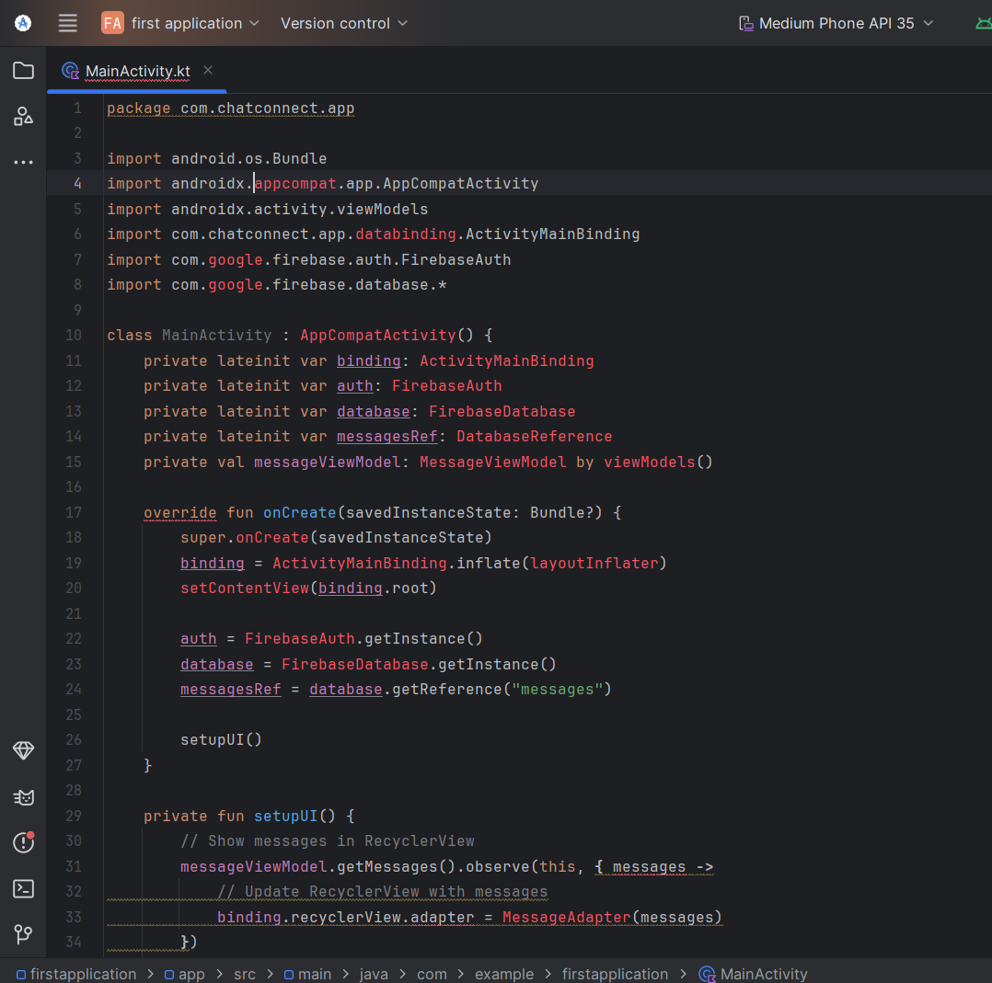

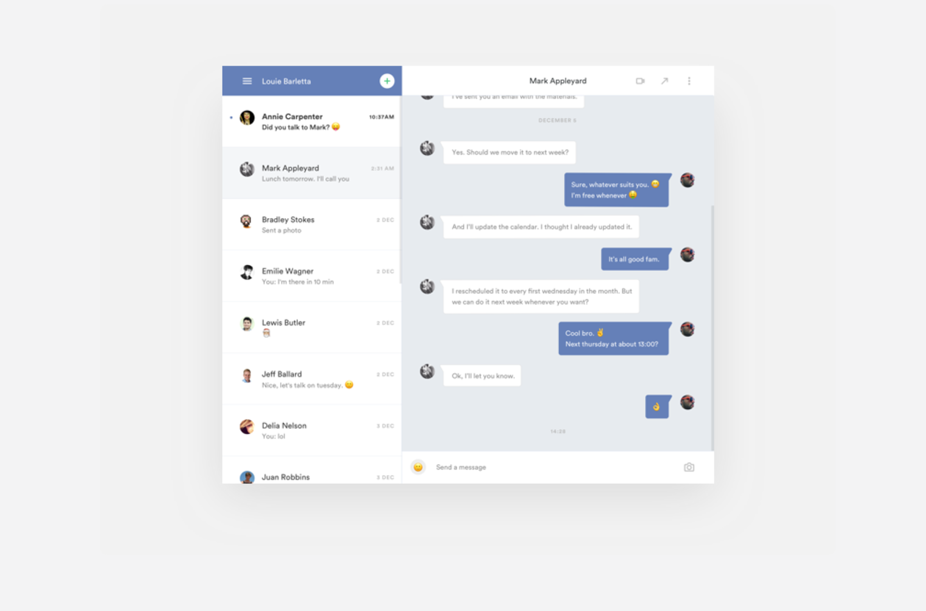

**Benefits of the Project**

The **ChatConnect - A Real-Time Chat and Communication App** brings several benefits to its users and developers alike. Some of the key advantages include:

1. **Real-Time Communication**:
   * The app provides users with a seamless and instant messaging experience. By integrating real-time communication features using Firebase and WebSockets, it allows users to send and receive messages in real-time, enhancing the user experience and making communication more effective.
2. **User Engagement and Connectivity**:
   * Users can easily connect and communicate with their friends, colleagues, or groups. The app fosters social interaction through features like text messaging, media sharing, and notifications, making it ideal for personal and professional use.
3. **Cross-Platform Accessibility**:
   * The app is designed to be cross-platform, which means users can access it from different devices (mobile phones, tablets, etc.). This enhances the app’s versatility and ensures that users are always connected, regardless of the device they use.
4. **Data Security and Privacy**:
   * The use of secure data protocols, including end-to-end encryption and secure Firebase database management, ensures that user data is kept private and protected from unauthorized access.
5. **Scalability**:
   * The app is built to scale efficiently, with Firebase’s real-time database allowing easy scaling as the user base grows. This ensures that the app can handle an increasing number of users and messages without performance issues.
6. **User-Friendly Interface**:
   * By using modern design practices and implementing Jetpack Compose for the UI, the app offers an intuitive and smooth user experience. This makes the app easy to navigate and ensures a pleasant interaction for users of all ages.
7. **Cost-Effective**:
   * Leveraging Firebase and Socket.IO for the backend minimizes the need for complex server infrastructure. Firebase’s pricing model is also cost-effective, offering scalable options for small to medium-scale applications.
8. **Flexibility**:
   * The app offers flexibility in terms of customization. Developers can easily extend features such as adding voice or video calls, implementing chat rooms, or introducing third-party integrations, based on user needs or future requirements.
9. **Real-Time Notifications**:
   * The app includes real-time push notifications to keep users updated about new messages, even when the app is in the background. This ensures that users do not miss important communications.
10. **Easy Integration with Other Services**:
    * ChatConnect can be integrated with other platforms or services for additional functionalities, such as integrating with Google services for authentication, or adding APIs for additional media sharing options (like file sharing or GIFs).

**Conclusion:**

In conclusion, the **ChatConnect** app provides a robust, real-time communication platform designed to meet the needs of modern digital communication. By leveraging the power of real-time data transfer technologies, it enables users to exchange messages, files, and multimedia instantly, enhancing both personal and professional interaction.

Through its user-friendly interface and efficient backend architecture, the app ensures smooth, seamless communication while providing essential features like message notifications, user authentication, and secure data storage.

The project demonstrates the practical application of several software development concepts, such as real-time communication protocols, database integration, and user interface design. It also highlights the importance of maintaining scalability, security, and user experience while developing communication tools.

In the future, the app can be expanded to include additional features, such as voice and video calling, group chat, and advanced encryption methods to further enhance the security and usability of the platform. With these improvements, **ChatConnect** can evolve into a comprehensive solution for communication across different devices and platforms.

Overall, the development of **ChatConnect** has been a valuable learning experience, showcasing the potential of real-time messaging technology in improving everyday communication.

**REFERENCE :**

1. "ChatConnect - A Real-Time Chat and Communication App." GitHub, 2024. Available at: <https://github.com/SUKU-DEVELOPER/ChatConnect---A-Real-Time-Chat-and-Communication-App/tree/720d608daded77b18cee5083fd08ab0b05d4ef9d/Chat-Connect-App-master/Chat-Connect-App-master>
2. Android Developers. "Building Your First App." Android Developers Documentation, 2024. Available at: <https://developer.android.com/training/basics/firstapp>
3. Firebase. "Firebase Real-time Database." Firebase Documentation, 2024. Available at: <https://firebase.google.com/docs/database>
4. "Socket.IO Documentation." Socket.IO, 2024. Available at: <https://socket.io/docs/>
5. "Android Jetpack Compose." Android Developers, 2024. Available at: <https://developer.android.com/jetpack/compose>
6. "Java Programming Language." Oracle, 2024. Available at: <https://www.oracle.com/java/>
7. "GitHub - A Platform for Software Development." GitHub, 2024. Available at: <https://github.com/>